Macroinvertebrate Image Analysis System
Software Technology 1 – Assessment 3 Part A
Group Members:
- u3298551
- u3258243
- u3330114

1. Project Goal
The goal of this project was to develop a modular Python application capable of analysing and visualising freshwater macroinvertebrate image datasets. The project focuses on Stage 1 (Exploratory Data Analysis) and Stage 3 (Application Deployment) of the assignment.
The system indexes image datasets, extracts metadata, generates exploratory data analysis outputs, detects dataset quality issues, and provides a Tkinter desktop GUI for user interaction.

2. System Design Overview
The project was designed using a modular object-oriented structure. Different responsibilities were separated into dedicated classes and modules to improve maintainability, readability, scalability, and testing.
The application workflow is:
- The GUI launches from main.py
- The DatasetIndexer recursively scans dataset folders
- Valid image files are loaded and indexed
- Image metadata is stored inside a Pandas dataframe
- EDAService generates visualisations and dataset summaries
- Generated outputs are displayed and saved automatically
The system was developed using multiple Python packages including Pandas, OpenCV, Matplotlib, Seaborn, Pillow, and Tkinter.

3. Class and Module Overview
“main.py” Acts as the entry point of the application and coordinates the GUI and backend workflow. And, “config.py” Stores reusable configuration settings such as dataset paths, output directories, and supported image extensions.

DatasetIndexer
Responsible for recursively scanning dataset folders, loading image files, extracting metadata, and building the main Pandas dataframe.
Extracted metadata includes:
- image width
- image height
- image channels
- image format
- class labels

EDAService
Responsible for generating exploratory data analysis outputs and dataset quality analysis.
Implemented features include:
- class distribution graphs
- image width and height analysis
- width vs height scatter plots
- boxplots by class
- pixel intensity histograms
- representative image grids
- dataset summaries
- dataset imbalance warnings
- low-resolution image warnings
GUI.py (MacroApp)
Implements the Tkinter desktop application.
The GUI supports:
- dataset indexing
- progress tracking
- image viewing
- image navigation
- displaying related text files
- automatic EDA generation
The GUI also uses threading to prevent freezing during indexing and analysis operations.
records.py
Defines the ImageRecord dataclass used for structured storage of image metadata.

4. Python Packages Used
Package | Purpose
Pandas | Dataframe storage and analysis
NumPy | Numerical operations
OpenCV | Image loading and metadata extraction
Matplotlib | Graph generation
Seaborn | Statistical visualisations
Pillow (PIL) | GUI image rendering
Tkinter | Desktop GUI development
pathlib | File and folder handling
threading | Background GUI processing

5. Key Features Implemented
Dataset Indexing
The application recursively scans dataset folders and automatically indexes valid image files.
Metadata Extraction
Image dimensions and class information are extracted and stored in a structured dataframe.
Exploratory Data Analysis
The system generates multiple visualisations and statistical summaries to analyse dataset structure and quality.
Dataset Quality Analysis
Warnings are generated for:
- class imbalance
- low-resolution images
- inconsistent image dimensions
GUI Deployment
A Tkinter desktop application was implemented to provide interactive dataset analysis and image browsing.
Threaded Processing
Background threading was implemented to keep the GUI responsive while indexing and EDA generation are running.

6. Object-Oriented Programming Principles
The project follows object-oriented programming principles including:
Encapsulation
Each class manages its own data and responsibilities.
Abstraction
Methods such as EDA generation hide internal implementation details from the main workflow.
Inheritance
The MacroApp GUI class inherits from Tkinter’s tk.Tk class.
Modularity
The application is separated into reusable modules including DatasetIndexer, EDAService, and GUI components.

7. Testing Summary
The project was tested multiple times throughout development.
Testing included:
- validating dataset indexing
- verifying dataframe creation
- testing corrupt image handling
- testing EDA output generation
- testing GUI image navigation
- testing progress tracking
- testing application shutdown behaviour
- testing output file generation
One issue identified during testing involved the Tkinter GUI shutdown process. Closing the GUI window initially caused the Python process to remain active in the VS Code terminal. This issue was resolved by implementing a custom cleanup function using quit() and destroy() to properly terminate the Tkinter event loop.

8. Sample Outputs
The system generates:
- class distribution graphs
- image size visualisations
- scatter plots
- sample image grids
- dataset summary outputs
- imbalance reports
- Examples of GUI and generated visuals
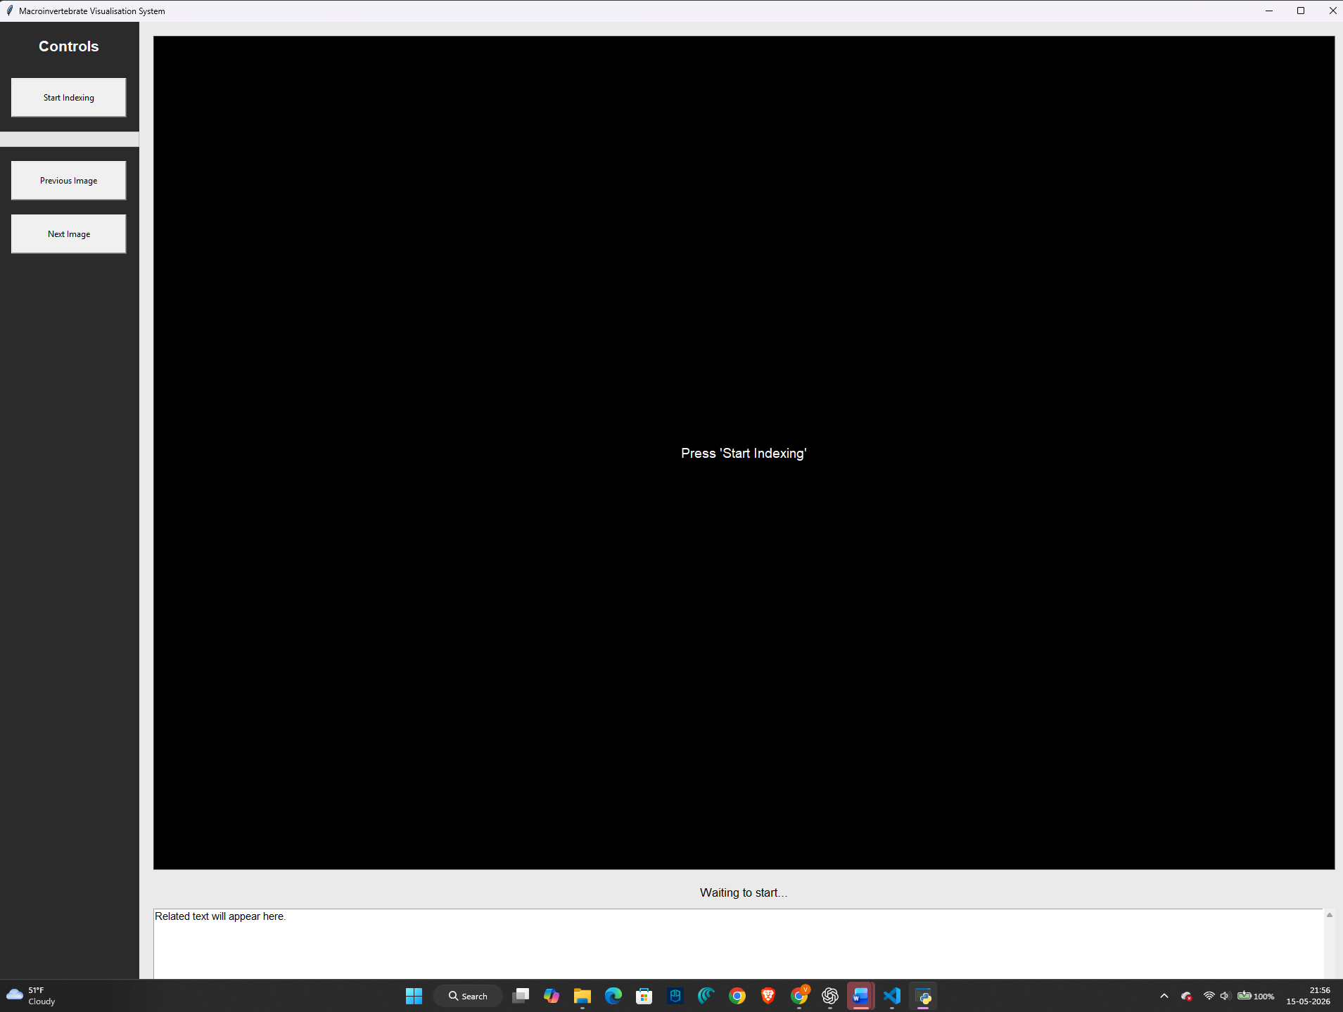
(The screenshot above shows the GUI of our application)

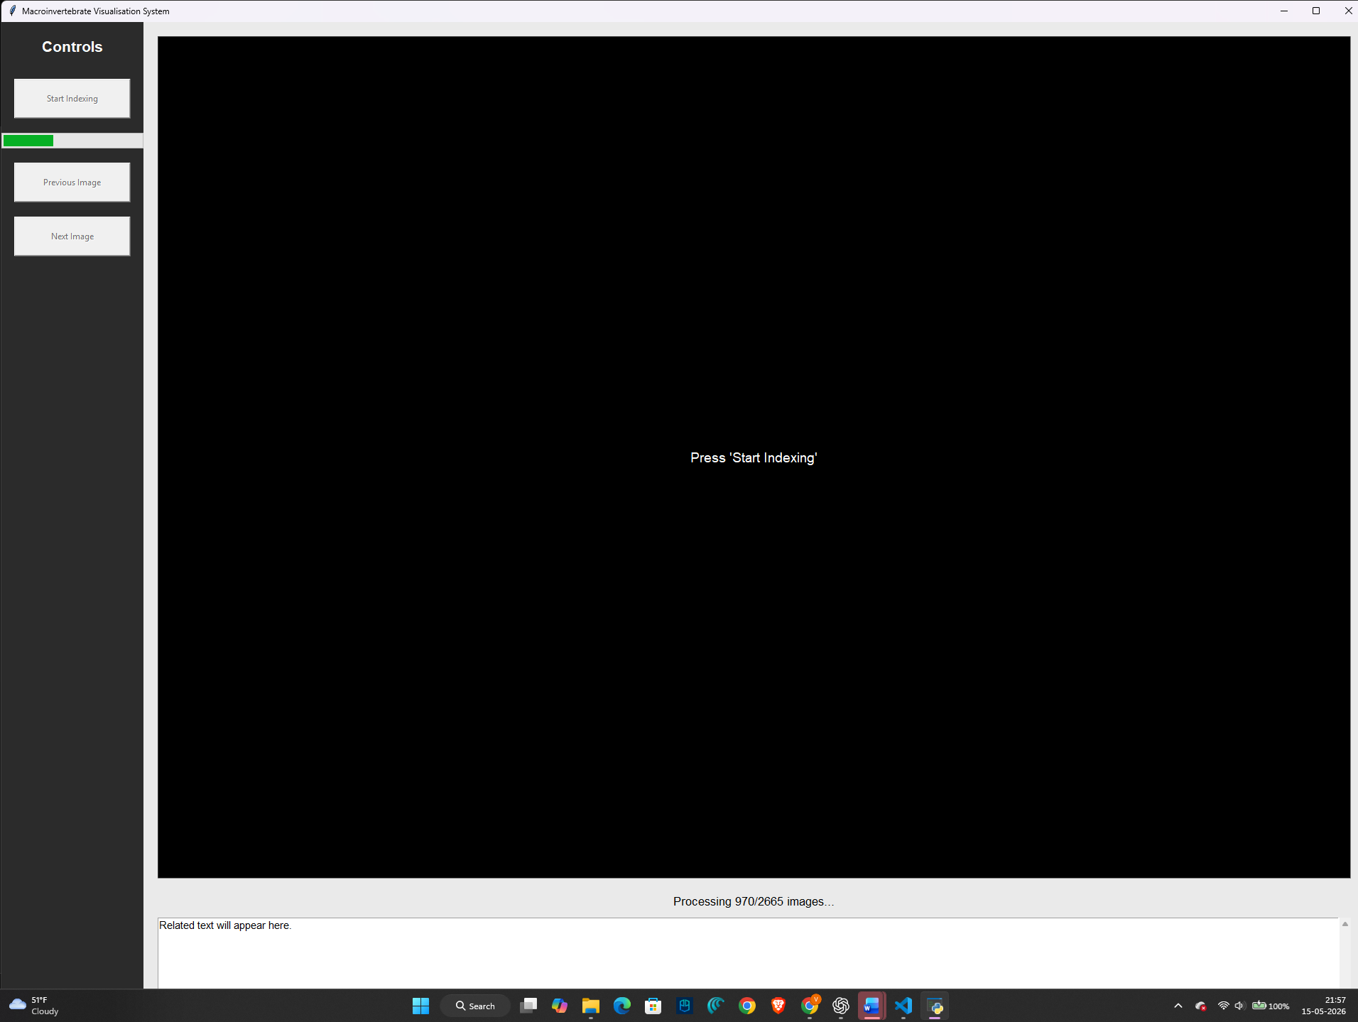
(The screen shot above shows the progress bar and count of the images that have been processed)
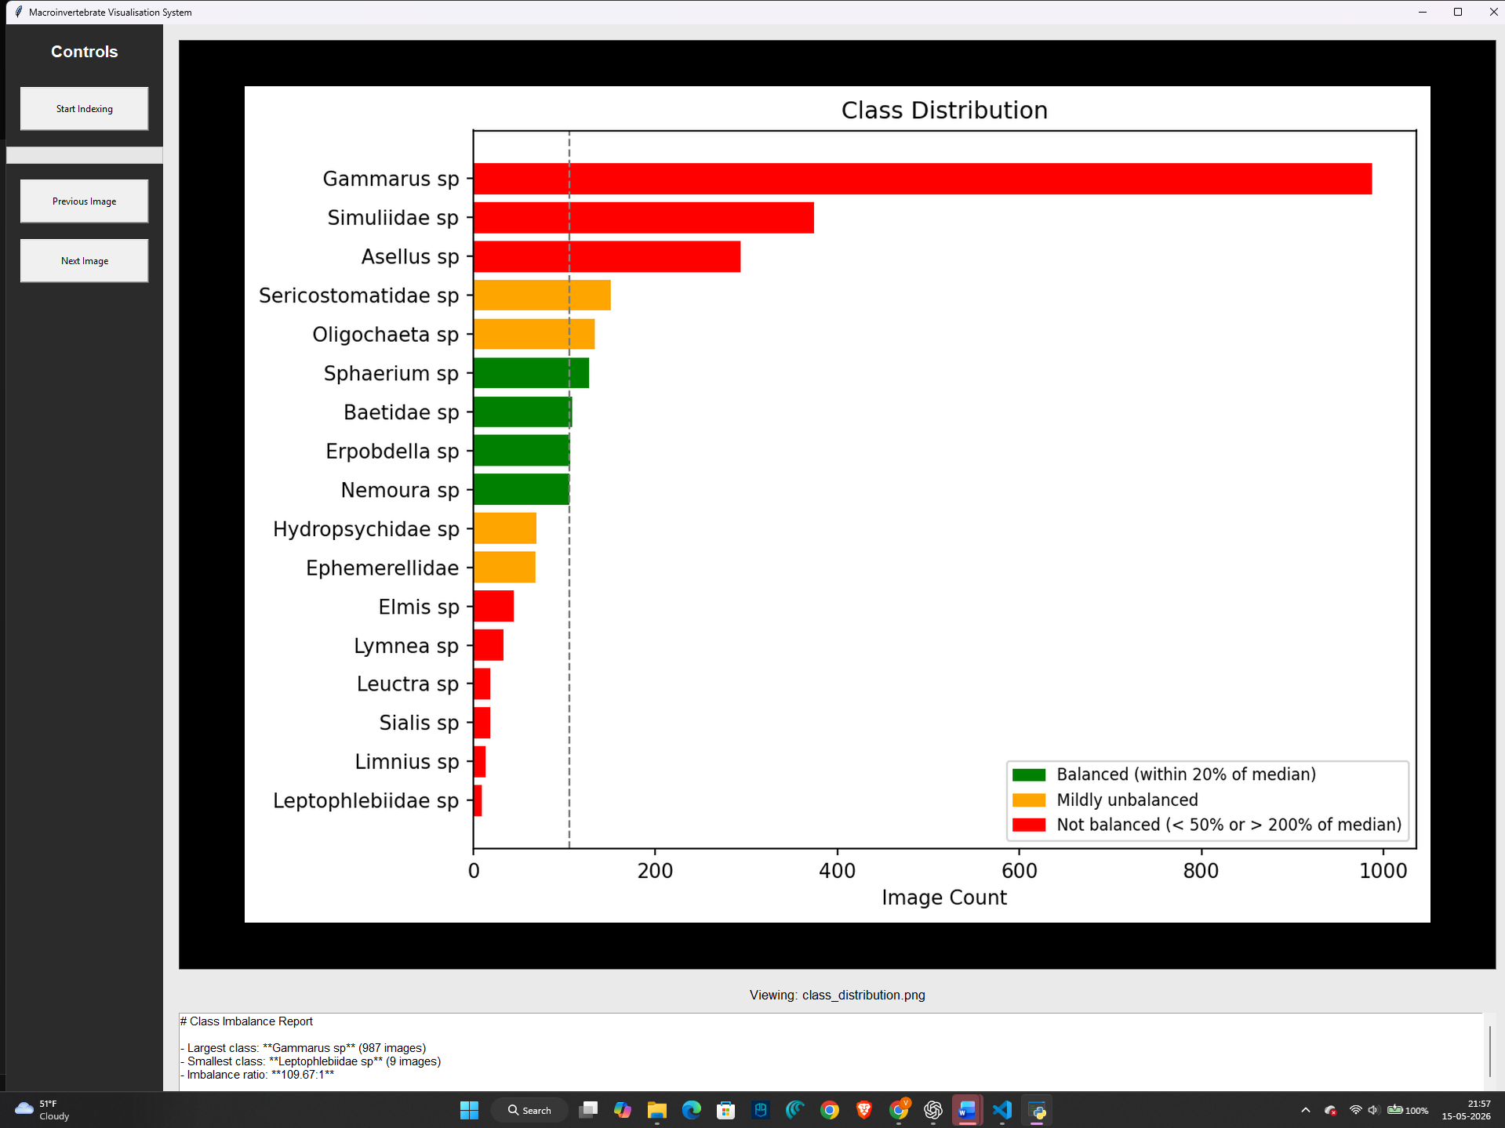

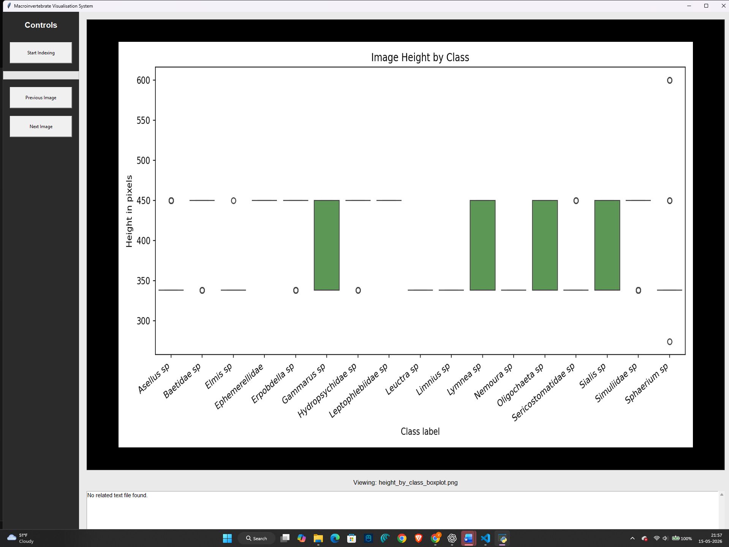

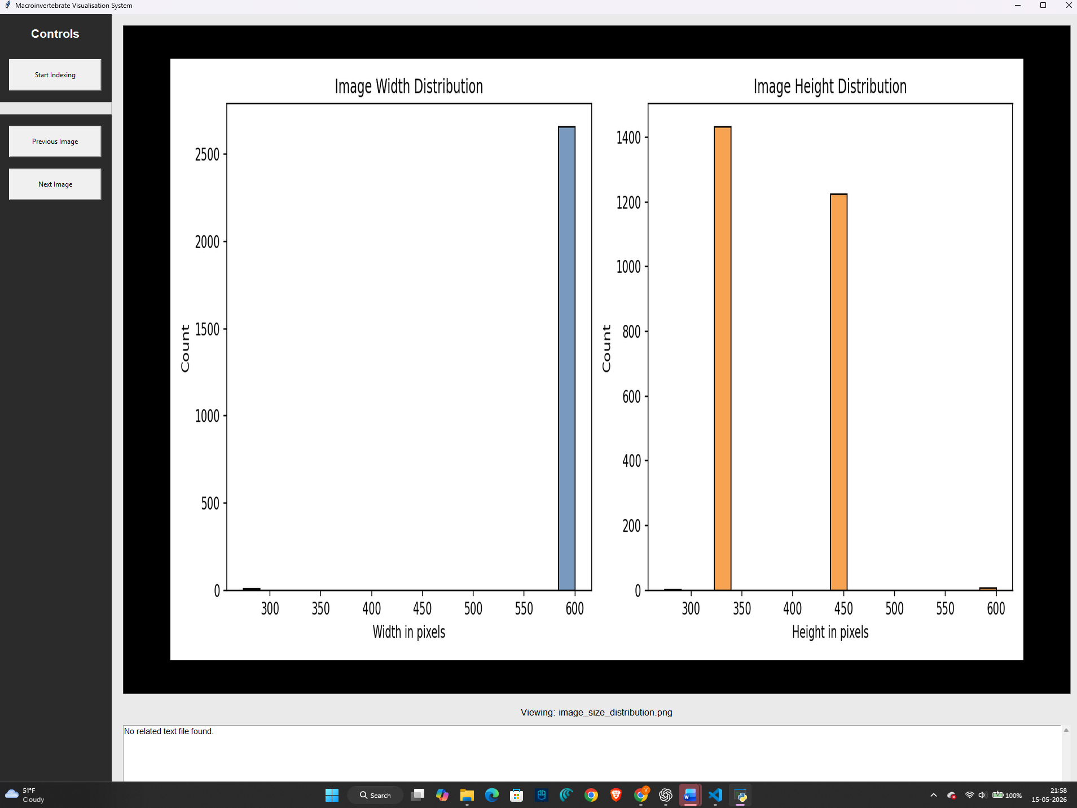

9. Reused or Adapted Code Acknowledgement
Some implementation ideas and structural approaches were adapted from weekly workshop materials, Python documentation, and library documentation including OpenCV, Tkinter, Pandas, and Matplotlib resources.
All reused concepts were modified and integrated into the project structure to fit the assignment requirements.

10) Work Division summary:

All group members contributed collaboratively throughout the project, including debugging, testing, integration, and overall system development.
Primary contributions included:
Member 1:
EDA implementation and GUI integration support.
Member 2:
GUI development and interface functionality.
Member 3:
EDA implementation (member 1 and 3 worked collaboratively) and dataset indexing development.
Although responsibilities were roughly divided, development and debugging were completed collaboratively across the entire project.

11. Conclusion
In conclusion, the project successfully implemented a modular Python application for macroinvertebrate image analysis and visualisation.
The final system demonstrates meaningful use of multiple Python packages, object-oriented programming principles, dataset indexing, exploratory data analysis, dataset quality analysis, and GUI deployment.
The project provides a strong foundation for future extension into predictive analytics and machine learning classification systems.

